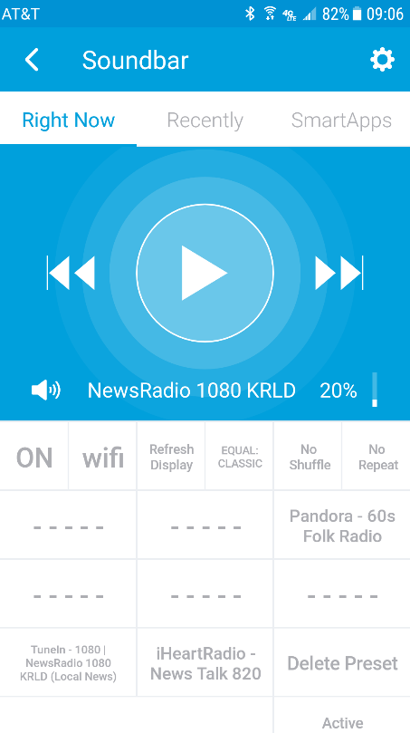

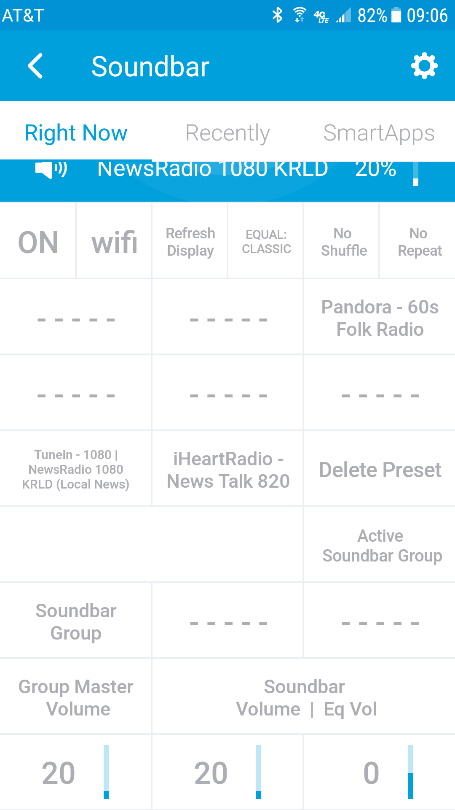

These instructions are for the installation of the Samsung WiFi Speaker/Soundbar into the SmartThings platform. The Service Manager and Device Handler were designed for and tested with two R-1 Speakers and one MS-650 Soundbar. It is also anticipated to work with other models. (Check with author.)

**INSTALLATION FILES**

0 - Device Handlers - Samsung WiFi Speaker DH.groovy

1 - Service Manager - Samsung WiFi Speaker SM.groovy

2 – Documents - Install - Samsung WiFi Speaker.pdf

Users Guide - Samsung WiFi Speaker.pdf

**PRE-REQUISITES**

- A compatible Samsung WiFi speaker already installed into the Samsung Multiroom application.

- A Samsung SmartThings “Developer Tools” account.

- For Presets, set up of stations or playlists as follows:

1. Amazon Prime Playlist. Have the playlists installed in: “My Music” > “Playlists”.

2. TuneIn. Have the desired stations installed in “Following” and designated as PRESETS.

3. iHeartRadio. Have the desired stations installed in “Favorites”.

4. Pandora. Have created the desired stations.

**BASIC INSTALLATION STEPS - Index**

A. Install the Device Handler into the SmartThings environment.

B. Install the Service Manager into the SmartThings environment.

C. Run the Service Manage.

D. Text-to-Speech Work-Around

**A. INSTALL THE DEVICE HANDLERS ON SMARTTHINGS**

1. Log in to SmartThings IDE. (You may have to create an acccount.)

2. After log in, go to "My Locations" and select your current location.

3. Go to "My Device Handler" and select "+ Create New Device Handler".

3. Select the tab "From Code".

4. Open the file “Samsung WiFi Speaker DH.groovy” and copy the contents.

5. Past the contents into the the IDE window. Select "Create" at the bottom.

6. On the next page that opens, click “Publish”, then “For Me” near the top-right of the page.

**B. INSTALL THE DEVICE HANDLERS ON SMARTTHINGS**

1. Log in to SmartThings IDE. (You may have to create an acccount.)

2. After log in, go to "My Locations" and select your current location.

3. Go to "My SmartAps" and select "+ Create New Device Handler".

3. Select the tab "From Code".

4. Open the file “Samsung WiFi Speaker SM.groovy” and copy the contents.

5. Past the contents into the the IDE window. Select "Create" at the bottom.

6. On the next page that opens, click “Publish”, then “For Me” near the top-right of the page.

**C.** Run the Service Manager

**[PLEASE OPEN UP 'LIVE LOGGING' AND IF AN ERROR OCCURS, PROVIDE THIS DATA TO AUTHOR WHEN REQUESTING ASSISTANTS]**

From your smart phone SmartThings application:

a. Select "Automation" (at bottom), then the 'SmartApps' tab.

b. Select '+ Add a SmartApp' at the bottom.

c. Select '+ My Apps' at the bottom

d. Select the app ‘Samsung WiFi Speaker SM (unofficial)'

e. In the upper right, select the Next text

f. Wait until the text “Select Speakers (n found)” has your number of speakers (this can take up to 5 minutes).

g. Select the area just below “Select Speakers”.

h. Select the speakers you want to install and then “Done”

i. Select Save. You should get a green alert “Successfully added ….”

j. Check that your speakers installed.

**D. TTS Capability Work-Around.**

|  |  |  |
| --- | --- | --- |
| 1 | **Phone**. Remove existing Samsung WiFi Speaker or Soundbar Installations from SmartThings. This includes the Device Handler and the Service Manager. | |
| 2 | Phone. Go to 'My Home - Add a Thing' install the "LAN SamsungAudio" versions of the spekers / soundbars. | |
| 3 | Create Surrogate Speakers | |
| 3 | a | Phone. Uninstall all **Soundbar** "LAN SamsungAudio" devices from SmartThings. |
| 3 | b | IDE. Change the DNI of all **Speaker** "LAN SamsungAudio" devices. (I add "ST-" in front of DNI.) |
| 5 | IDE. Replace the existing device handler 'Samsung WiFi Speaker (Unofficial)' with the new one ' Samsung WiFi Speaker (Unofficial-V2)' (Edit device handler and replace text). Save and Publish. | |
| 6 | Phone. 'Remove' the existing "Samsung WiFi Speaker SM (Unofficial)'. **[This is required to remove old data from the system.]** | |
| 7 | IDE, replace the existing Smart App (Service Manager) 'Samsung WiFi Speaker SM (Unofficial)' with the new one 'Samsung WiFi Speaker SM (Unofficial-V2)'. Save and Publish. | |
| 8 | Phone. Add the Service Manager 'Samsung WiFi Speaker SM (Unofficial-V2) ' to the ''Automation - SmartApps'. | |
| 8 | a | For each "LAN SamsungAudio" device, associate it with a single 'tts_n' speaker. [This is required to allow the new speaker device handlers to pass TTS text to the 'all "LAN SamsungAudio" devices.] |
| 8 | b | Select 'Next' (upper left corner) then follow the normal installation procedure. |
| 9 | Phone. 'My Home'. For each speaker, select the device details page, then the setting page for the device. In this page ,you MUST select 'Surrogate Speaker for TTS'. This is the id assigned in the service manager when installing the devices (step 8a). | |

**E. Adding and Deleting Presets**

Preset Management has been added to the program that allows the use to add and delete presets (with some limitations.

I. TO ADD A PRESET

a. Find a preset with identification "vacant"

b. Have the channel/playlist playing on the speaker. Path limitations:

1. Amazon. playlists in "Playlists".

2. Amazon Prime. Playlists in "Playlists" or in <"My Music", "Playlists">

3. Other content players. Programed for default, w/o limitation. May not work. If it works, great. If not, contact author.

c. Press the "vacant" preset tile. Text will change to "Add Preset?"

d. Press the preset tile again. Text will change to "updating" followed by title.

e. To not add the preset, do NOT press the preset tile a second time.

II. TO ADD A GROUP PRESET

a. Set up the group, stereo, or surround system in the MultiRoom App.

b. Press the desired preset button (will be “- - - - -“).

c. Press the button again.

d. The preset will be active in SmartThings once created.

[Note. To stop a preset, press the tile with “Active” in the first line. You will have to press this tile twice to confirm turning off.

III. TO DELETE A PRESET.

a. Press the "Delete Preset" tile. Text will change to "SELECT PRESET TO DELETE". If you press this, the process will abort.

b. Press the preset you want to delete. Text on the Delete Preset tile will change to "PRESS TO DELETE preset_n".

c. Press the Delete Preset tile again (within 10 seconds) to delete the preset.

**F. Implementation Notes**

1. When using the Multiroom app to start music, when entering the app, depress “Update Display”. This will update the interface for the chosen player.

2. Presets sometimes hangs (the command is not acted upon). Reason unknown. Try again after about 5 seconds.

3. Display of status is slow and sometimes SmartThings does not parse nor update the display. Use Update Display to force this action.

4. Music Player functionality depends upon the player. See below.



5. Music Play is generally available in all of the above. All functions are available for your local DLNA players identified in the Multiroom app. For HDMI, Bluetooth, Auxiliary, and HDMI(ARC)/Optical, the play/pause function does not work.